Food Safety for Carriers
Sanitary Transportation of Human and Animal Food

U.S. Food and Drug Administration
10903 New Hampshire Avenue
Silver Springs, MD 20993
1-888-INFO-FDA (1-888-463-6332)

Introduction

In 2016, the FDA issued regulations that apply to shipper, loaders, receivers and carriers engaged in the transportation of foods by motor vehicle or rail vehicle in the United States. FDA’s Final Rule on Sanitary Transportation of Human and Animal Food (the Sanitary Transportation Rule or ST Rule) and other rules established under the Food Safety Modernization Act of 2011focus on the Prevention of food safety problems throughout the food supply. The Sanitary Transportation Rule requires carrier firms to provide basic food safety training to personnel engaged in food transportation operations.

Sanitary Transportation Rule

While not frequent, outbreaks of food borne illnesses and injury have been associated with unsanitary transport of food. Failure to protect food from contamination and temperature abuse during any point from harvest to consumption, including transportation, increases the risk that food will cause an outbreak among humans or animals.
Who is covered by the Sanitary Transportation Rule?
The rule applies to businesses that act as shippers, receivers, loaders or carriers in the transport of human or animal food of the United States by motor or rail vehicles, whether or not the food is offered for sale or enters into interstate commerce.
It also applies to persons who ship food to the United States directly by motor or rail vehicles, by ship, or by air and arranges for the transfer of the intact container onto a motor or rail vehicle for transportation with it U.S., if that food will be consumed or distributed in the United States.
However, many types of food transportation operations are not covered by the Sanitary Transportation Rule.
Sanitary Transportation Rule does not apply to:

- Transportation of food that is completely enclosed by a container unless the food requires temperature control for safety.
- Transportation of compressed food gases (e.g. ,carbon dioxide, nitrogen or oxygen authorized for use in food and beverage products)
- Transportation of food contact substances
- Transportation of live food animals, except mollusc an shellfish]
- Transportation activities preformed by a farm
- Transportation of human food by products for use as animal food without further processing
- Transportation of food that is transhipped through the united States to another country
- Transportation of food that is imported for future export and that is neither consumed or distributed in the United States
- Firms that have less than $500,000 in average annual revenue

Critical Elements of the Sanitary Transportation Rule

Vehicles and Transportation – vehicles and transportation equipment must be designed and maintained so as not to cause the food that is transported to become unsafe. For example, the vehicle, and transportation equipment must be suitable and adequately cleanable for their intended use and capable of maintaining temperatures necessary for the safe transport of food.
Training – When the carrier and shipper have agreed in a written contract that the carrier is responsible, in whole or in part for the sanitary conditions during transportation operations, the carrier must provide the training or potential food safety problems and the basic sanitary transportation practices to personnel engaged in the transportation operations. The training must provided upon hire and as needed thereafter.
Records – Shippers and carriers bear responsibility for maintenance of various records of written procedures, agreements and in the case of carriers training that is documented. The nature of the required records is defined in the sanitary Transportation Rule.

Understanding your Responsibilities under the Sanitary Transportation Rule

The sanitary Transportation Rule places much of the responsibility for establishing safe food transportation procedures on the shipper. For example, the shipper must develop and implement written procedures that adequately ensure that:
- Vehicles and equipment used in its transportation operations are in appropriate sanitary condition for the transport of food and prevent the food from becoming unsafe during the transportation operation;
- A previous cargo does not make the food unsafe; and
- The food is transported under adequate temperature control, when necessary, to insure food safety.
The carrier will often be responsible for implementing these procedures under a written agreement between the shipper and the carrier, such as making sure that the vehicle and or cargo is maintained at or below the temperatures specified by the shipper.
Carrier personnel engaged in the food transportation operations should follow the procedures established by the shipper and the carrier, as required by the Sanitary Transportation Rule, to prevent food from becoming unsafe during transportation operations.

Responsibilities of all parties
The Sanitary Transportation Rule establishes a requirement for any party hat becomes aware of a food safety problem. The Sanitary Transportation Rule States:
If a carrier, shipper, loader or receiver becomes aware of a possible material failure of temperature control or other conditions that may render the food unsafe during transportation, the food shall not be sold or otherwise distributed, and these persons must take appropriate actions including, as necessary, communication with other parties to ensure that the food is not sold or otherwise distributed unless a determination is made by a qualified individual that the temperature deviation or other conditions did not render the food unsafe.

Carrier personnel should follow the procedures established by the carrier for reporting conditions that may render food unsafe and for taking corrective action as needed.
Food Safety Hazards Associated with Transportation
Contamination of human or animal food can result in people and animals becoming ill or injured. It is the responsibly of all personnel directly involved with the transportation of food to ensure that foods are protected from contamination. This includes contaminates that may be introduced from the facilities, equipment, and/or the environment in which the food is stored and from the persons who are handling and managing food cargoes.
Food contamination are often categorized as:
- Physical
- Chemical
- Microbiological

Potential Sources of Contamination: Vehicles and Equipment
Examples of potential sources of contamination from equipment and surfaces that may come into contact with food and food contact surfaces include:
- Soil and debris on floors, walls and ceiling of transport vehicles.
- Soiled lifts, hooks and tools used to move food not completed enclosed by a container.
- Poorly maintained and not easily cleanable food containers, equipment, and transport vehicles.

Potential Upkeep of Transportation Units

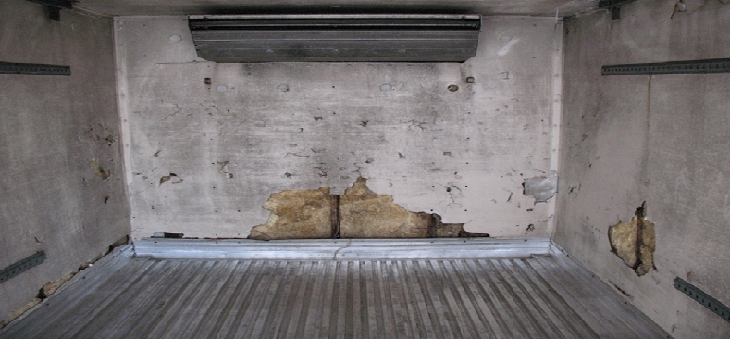
This photo shows the inside of a motor vehicle transporting exposed food. The walls have an exposed, fibrous insulation where the metal sheeting of the wall has been damaged
Tough to Clean Areas and Pests
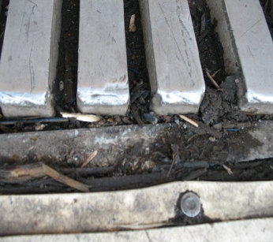
Dirt and broken wood pieces indicate poor cleaning methods and damaged hauling vehicles.
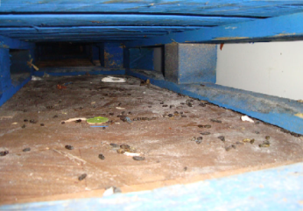
Rodent excreta pellets, nesting materials, and food product spillage were found under pallets indicating unsanitary conditions exist.

Potential Sources of Contamination: Chemicals

Improper storage or application of chemicals can contaminate exposed foods. Chemical contamination of food can cause injury and illness to humans and animals.
Potential sources of chemicals contamination include;

- Using chemicals that are not EPA-registered when sanitizing food contact surfaces.
- Not using cleaning and sanitizing chemicals in accordance with approved label instructions.
- Not using pesticides and rodenticides in accordance with the approved label instructions
- Not keeping fuels, fumes and industrial chemicals away from exposed foods
- Offering a bulk vehicle previously used in the transport of medical animal feeds that has not undergone a clean out that is capable of removing animal feeds that has not undergone a clean out that is capable of removing animal drug residue.

Potential Sources of Contamination: Pests

Droppings from pests such as insects, rodents and birds can be a source of microbiological and physical contamination of foods and food contact surfaces. Contamination of food by pests can result if carriers fail to:
- Keep food vehicles and containers free from pests
- Protect the interior of vehicles and containers against pest activity during periods of storage and non-use.
- Regularly monitor the environment and apply aggressive control measures when pest activity is detected.
- Eliminate pest harborage materials, such as corrugated cardboard, plastic wrap and paper pallet liners wherever possible.

Improper Sanitation
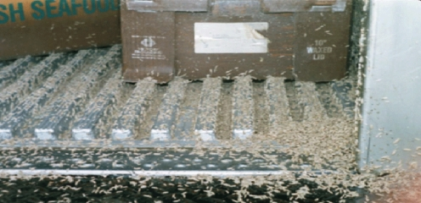
This photo shoes small insect larvae on the floor, walls and outside of food product containers being transported in a motor vehicle. In addition to being an indication of poor sanitation, this may suggest that the food product was not kept at the proper temperature during transport further investigation to determine the food was adulterated is necessary.

Potential Sources of Contamination: Poor Personal Hygiene

Personnel involved in handling exposed food can cause contaminations through the following:
- Soiled hands and arms
- Unrestrained hair and beards
- Discharge from nose and mouth
- Soil from unsanitary clothing
- Physical objects on personnel, such as jewelry , artificial nails, and buttons
Foods contaminates may result from failing to follow these good hygiene practices:
- Routinely washing hands at suitable hand washing facilities, especially after using the rest room and before working with exposed food.
- Changing soiled uniforms and clothing as needed
- Using hats, hair nets, or beard guards.

Potential Sources of Contamination: Loading Practices

Unsanitary loading practices can lead to contamination of human and animal food. Examples Include:
- Loading and Unloading of vehicles and containers increased the likelihood that the food may be exposed to cross-contamination from shipping personnel and material handling equipment if sanitary practices are not followed
- Loading and unloading activities may expose food products to extreme variations in temperature unless the necessary precautions are taken to limit the time when refrigerated foods are staged for loading on unrefrigerated loading docks
- Failing to properly maintain equipment used in bulk food transfer operations, including items such as pumps and hoses.
Protecting Food from Non-Food Items during Transportation

Human and animal products are often shipped in less than truckload (LTL) shipments. This may result in shipping exposed food products with other types of raw foods or non-food items.

- Certain non-food products may pose chemical, physical, or microbiological hazards. For example:

- Cleaning chemicals may be considered a chemical hazard

- Items that are not food, such as lumber and plastics, pose a physical hazard if co-mingled with the food products

- Organic fertilizers, a non-food product that may contain manure, may pose a microbiological hazard.

Potential Contamination: Other Foods

It is important to protect one food from being contaminated by another food during transportation operations, especially foods shipped in bulk vehicles that have previously hauled other types of food.
- Raw foods may contain harmful microorganisms that may contaminate unprotected ready-to-eat foods that won’t be cooked before they are eaten.
- Spoiled foods and other foods scheduled for disposal or salvage may contaminate other foods if permitted to come in contact.
- If a food allergen is transported in a vehicle, especially in bulk, that allergen could contaminate subsequent loads, which could lead to life-threatening reactions in individuals allergic to the allergen.

What is Cross-Contamination?

The term cross-contamination is commonly used to describe the transfer of harmful bacteria or toxins from one food to another food. The transfer could come from direct contact between the foods or their drippings or from sequential contact with a vehicle or equipment surface that has not been properly cleaned. The hazard is greatest when raw foods such as meat and poultry cross-contamination that foods that intended to be eaten without further cooking or processing.

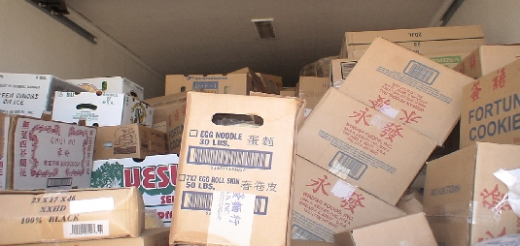

Cross-Contamination within a Single Load

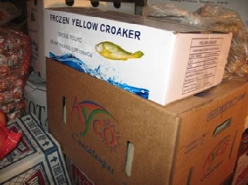
Cross-contamination can occur during transportation when exposed ready-to-eat foods are not adequately separated from foods that are not ready-to-eat (such as raw foods of animal origin and certain raw agricultural commodities)
The risk of cross-contamination may be increased if carriers fail to:
- Use physical barriers such as bulk-heads separators, partitions and appropriate curtains,
- Verify the integrity of containers and properly secure loads to prevent damage to containers and wrapping materials,
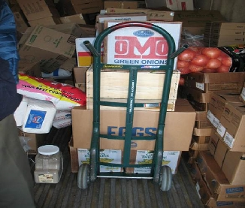
- Create adequate spacing between different commodities, especially between different commodities, especially between raw foods and ready-to-eat foods.

Preventing Cross-Contamination

Carr must be taken when exposed raw foods are to be transported on the same vehicle with exposed ready-to-eat foods.

Ways to prevent cross-contamination include:
- Separate different commodities by using adequate spacing, physical dividers or packaging materials to prevent cross-contamination.
- Avoid contact between different types of food during loading and unloading of the vehicle.
- If ice is used to provide cold holding of raw foods such as meat and fish, taking care to ensure drainage from melting ice does not contact other foods and containers.

Preventing Cross-Contamination from Prior Loads

Under the Sanitary Transportation Rule, carriers are responsible for ensuring that vehicles and equipment meet the shipper’s specifications and are appropriate to prevent food from becoming unsafe.

Carrier personnel should follow their company procedure for:
- Cleaning, sanitizing and inspecting vehicles between loads
- Maintaining appropriate documentation as specified, to indentify the previous cargo transported in a bulk vehicle.
- Maintaining documentation, as specified, to describe the most cleaning of a bulk vehicle.
- Using dedicated vehicles and tankers for specific types of food commodities, as appropriate.

Proper Cleaning of Transport Vehicles

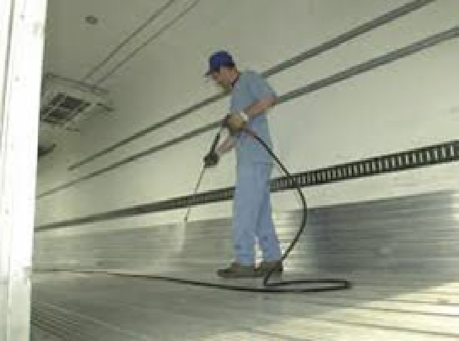
This photo shows the use of a power washer to clean the inside surfaces of the trailer used to transport food. Written procedures for cleaning and inspecting vehicles and transportation equipment are required by the rule. Following these procedures will reduce the likelihood of cross-contamination and cross-contact.

What is Cross-Contact?
The term cross-contact is used to describe the unintentional introduction of a food allergen into human food. Cross-contact can occur when type of food comes into contact with another type of foods, either directly or via sequential contact with the same vehicle or equipment surfaces, and one of contains and allergen that is not intended to be present in the other.
Dangers of Cross-Contact and Allergen Hazards
Protecting against cross-contact is important:
- Food Allergens can cause serious, even life-threatening reactions.
- For those who have food allergies, the only way to prevent harmful consequences is to avoid those foods to which they are allergic and other foods that may contain the allergen.
- Food allergic individuals must rely on the accuracy of food labeling to know exactly what is in the food they consume and to avoid consuming even small amounts of food allergens.
Note: Preventing allergen cross-Contact is a concern primarily with “human foods”. Preventing allergen cross-contact is not a concern when transporting foods for animals.

Major Food Allergens

Many foods can cause allergic reactions in individuals with foods allergies. The FDA seeks to reduce allergic reactions by making sure food allergens are properly managed in food facilities and that the 8 most common food allergens are properly declared on food product labels. These 8 foods of food groups were identified in the Food Allergen Labeling Control and Prevention Act (FALCPA) as those most likely to cause allergic reactions.
- Milk
- Eggs
- Fish (i.e., bass, flounder, and cod)
- Crustacean shellfish (i.e., crab. Lobster, and shrimp)
- Tree nuts (i.e., almonds, walnuts and pecans)
- Peanuts,
- Wheat
- Soybean
Carriers should take particular care in following procedures established by shippers to minimize the potential for cross-contact when transporting human foods that are not completely enclosed by a container.
Prevent Cross-Contact
It is important to properly clean vehicles and transportation equipment after transporting foods that contain major food allergen. Prior to transportation food that is not completely enclosed by a container, it is important to make sure that the vehicles and transportation equipment are clean, and that even small amounts of food allergens from prior cargoes have been removed.
This means:
- Understanding who has the responsibility for cleaning the food storage areas of the transportation vehicle between shipments
- Verifying that transportation vehicles were properly cleaned between shipments in accordance with procedures specified by the shipper.
- Strictly adhering to company policy with regards to the use of dedicated vehicles for the transport of certain bulk commodities.
- Unless completely enclosed by a container, verifying that foods that contain a major allergen are not stored above or in close proximity to other foods that are not completely enclosed in a container.
- Verifying integrity of packaging and containers in which food is stored to ensure that damaged containers do not create cross-contact situations
What foods require Temperature Control Safety?

Understanding what types of foods require temperature control for safety and preventing temperature abuse of those foods is the responsibility of the individuals involved in the transportation of such foods.
While some foods are kept cold to prevent spoilage and to extend shelf life, certain foods must be kept cold during transportation to prevent harmful bacteria from multiplying in the food.
Foods that require temperature control for safety generally include:
- Meat , poultry fish and other foods of animal origin (raw or previously cooked)
- Foods of plant origin that have been cooked
- Raw seed sprouts
- Cut melons
- Cut leafy greens
- Cut tomatoes
- Garlic-in-oil mixtures

*Note: many of these foods can be modified or packaged in a manner such that they no longer require temperature control for safety. For example, most canned meats, fish and soups are shelf stable and do not need temperature control for safety.

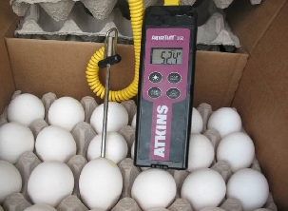
Transporting Foods the Require Temperature Control for Safety
Certain types of foods must be stored and transported under temperature control to prevent the growth of harmful microorganisms that may be present in food
Transporting such foods without proper temperature control makes it more likely that the food will cause people or animals to become ill.

Under the Sanitary Transport Rule, It is the responsibility of the shipper to specify to the carrier if a food to be transported is one that requires Temperature Control for safety.

Maintaining Proper Temperature
Ensuring proper temperature control is necessary to prevent undesirable microorganisms from multiplying in certain types of food:
- The shipper must establish measures to ensure certain foods are maintained at the proper temperature during transportation operations. In general, this includes specifying an operating temperature, in writing to the carrier, for foods that require temperature control for safety.
- Actions by the carrier, loader, and receiver personnel may be required to implement these measures to effectively ensure adequate temperature control.
- A carrier is required to have written procedures that describe how it demonstrates that it has maintained temperature conditions consistent with the operating temperature specified by the shipper.
- Not only is it important to make sure the transport vehicle is properly maintained and temperature controlled, but the length of time for loading and unloading without proper refrigeration can impact food safety. Personnel involved in loading should follow procedures specified by the shipper and carrier,
Proper Temperature Control
The Sanitary Transportation Rule itself does not establish the specific methods that must be employed by a carrier to maintain and monitor the temperature of transportation vehicles and food cargoes. Instead it requires the carrier to:
- Ensure that the vehicles and transportation equipment meet the appropriate specifications of the shipper.
- Pre-cool each mechanically refrigerated cold storage compartment as specified by the shipper, before offering a vehicle or equipment for use in transporting food that require temperature control for safety .
- Provide , if requested by the receiver upon completion of the transportation operation the operating temperature specified buy the shipper;
- Demonstrate, if requested by the shipper or receiver upon completion of the transportation operation, that the operating temperature specified by the shipper has been maintained during transportation operations. Such demonstration shall be accomplished by a means agreeable to the carrier and the shipper. For example, presenting measurements of the ambient temperature upon loading and unloading and/or temperature measurements taken during shipment.

Potential Temperature Abuse
Foods may be subject to temperature abuse as a result of:
- Transporting foods using equipment or procedures that are not capable of maintaining the operating temperature, when specified
- When transporting foods in mechanically-refrigerated cold storage compartments, failing to properly pre-cool the compartments as specified by the shipper
- Failing to properly use ice, dry ice, insulated coolers, or other measures, when specified, to maintain adequate temperature control.
- Inadequate quantities of ice when used to cold hold food products requiring refrigeration.
- Failing to operate refrigeration equipment as intended
- Loading the storage compartment in a manner that restricts adequate air circulation needed for proper cooling

Preventing Temperature abuse of Foods during Transport
Safety steps that will ensure adequate temperature control for food that require temperature control:
- Know what foods require temperature control for safety
- Verify that equipment is functioning properly
- Verify compartment and/or product temperatures as specified in shipper or carrier procedures
- Regularly monitor the calibration of temperature control and measurement devices
- Visually inspect product stored in ice to ensure proper cold holding.

Preventing Temperature Abuse
The shipment of temperature control for safety foods may require additional measures to prevent bacteria growth during transportation. Carrier personnel should be aware of and follow any company procedures that address proper temperature control.
- Long distance transportation of food may involve several stops to drop-off and pick up additional loads. This may require additional refrigerated storage facilities and load management methods to consider when controlling temperature
- Contingency procedures may be necessary for when unforeseen delays in delivery or equipment failures take place that may compromise the ability of a carrier to maintain temperature controls. Implementing such procedures will help insure that foods require temperature control for safety will not be subject to temperature conditions that may render the food unsafe.

Summary
- Motor Vehicle and rail carriers play an important role in protecting the safety of the food supply.
- The actions taken by carrier personnel can help prevent people and animals from getting sick or injured from foods they east
- Understanding how to transport food in a safe and sanitary manner is the responsibility of all carrier personnel
- Following required safe food transportation procedures and calling attention to potential problems can save lives.

